**What Are E-cigarettes (vaping devices)?**

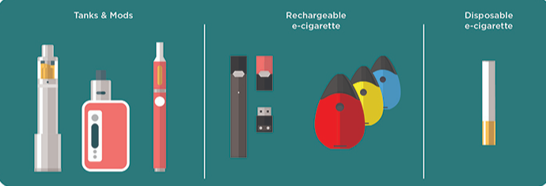

*pictured above: different vaping devices currently on the market (CDC 2019).*

* **Hunterdon County schools ranked teen vaping as the number one problem.** *(Key Informant 2019)*
* **The US Surgeon General** **declared e-cigarette (vape) use among youth a *national epidemic*.**
* According to the CDC and FDA, lung illness and death has been attributed to vaping.
* The act of using one of these devices is often referred to as “vaping” or “JUULing”.
* **One JUUL pod contains as much nicotine as 20 cigarettes**.
* **A common misconception** **is that e-cigarettes are just water vapor and flavoring.**
* E-cigarettes are electronic devices that heat a liquid (e-juice) to produce an *aerosol.* Users inhale this non-FDA regulated *aerosol*.
* The liquids used to create this aerosol are made using chemicals, additives, and mind altering substances. They can include nicotine, diacetyl, and THC.
* They are known by many different names. They are sometimes called “e-cigs,” “e-hookahs,” “mods,” vape pens,” “take systems,” and “electronic nicotine delivery systems (ENDS).”
* These devices come in in many shapes, sizes, and colors. Some look like cigarettes, cigars, or pipes. Some are extremely discrete, and look like USB flash drives, pens, and other everyday items.
* **Most youth do not know the ingredients in these products.**
* Products that claim they are nicotine-free may contain nicotine due to lack of regulation.
* **Nicotine exposure during adolescence can harm the brain, which is still developing up to age 25.**
* Teen nicotine use increases the likelihood of future drug use, including tobacco products and marijuana.

*All of the information presented in this document was gathered directly from the Center for Disease Control (CDC) unless otherwise specified. All facts and statistics were updated by the CDC in 2019 to reflect the most up to date research on e-cigarette devices.*

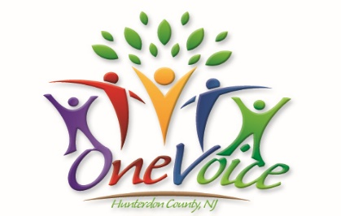

**What Are E-cigarettes (vaping devices)?**



*pictured above: different vaping devices currently on the market (CDC 2019).*

* **Hunterdon County schools ranked teen vaping as the number one problem.** *(Key Informant 2019)*
* **The US Surgeon General** **declared e-cigarette (vape) use among youth a *national epidemic*.**
* According to the CDC and FDA, lung illness and death has been attributed to vaping.
* The act of using one of these devices is often referred to as “vaping” or “JUULing”.
* **One JUUL pod contains as much nicotine as 20 cigarettes**.
* **A common misconception** **is that e-cigarettes are just water vapor and flavoring.**
* E-cigarettes are electronic devices that heat a liquid (e-juice) to produce an *aerosol.* Users inhale this non-FDA regulated *aerosol*.
* The liquids used to create this aerosol are made using chemicals, additives, and mind altering substances. They can include nicotine, diacetyl, and THC.
* They are known by many different names. They are sometimes called “e-cigs,” “e-hookahs,” “mods,” vape pens,” “take systems,” and “electronic nicotine delivery systems (ENDS).”
* These devices come in in many shapes, sizes, and colors. Some look like cigarettes, cigars, or pipes. Some are extremely discrete, and look like USB flash drives, pens, and other everyday items.
* **Most youth do not know the ingredients in these products.**
* Products that claim they are nicotine-free may contain nicotine due to lack of regulation.
* **Nicotine exposure during adolescence can harm the brain, which is still developing up to age 25.**
* Teen nicotine use increases the likelihood of future drug use, including tobacco products and marijuana.

*All of the information presented in this document was gathered directly from the Center for Disease Control (CDC) unless otherwise specified. All facts and statistics were updated by the CDC in 2019 to reflect the most up to date research on e-cigarette devices.*

